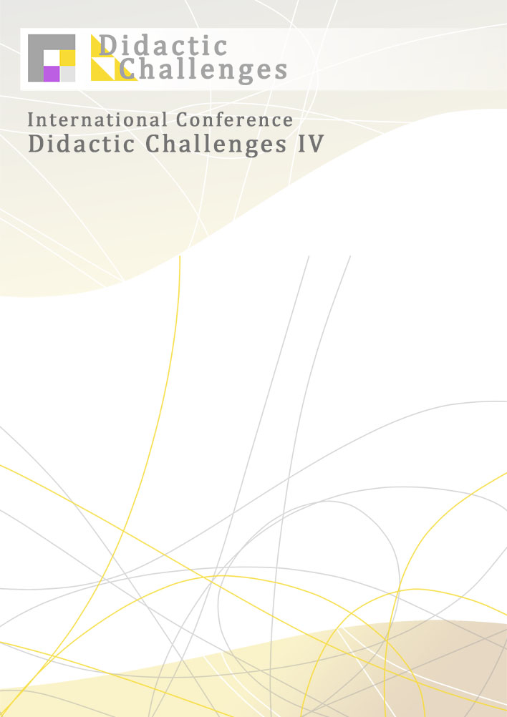
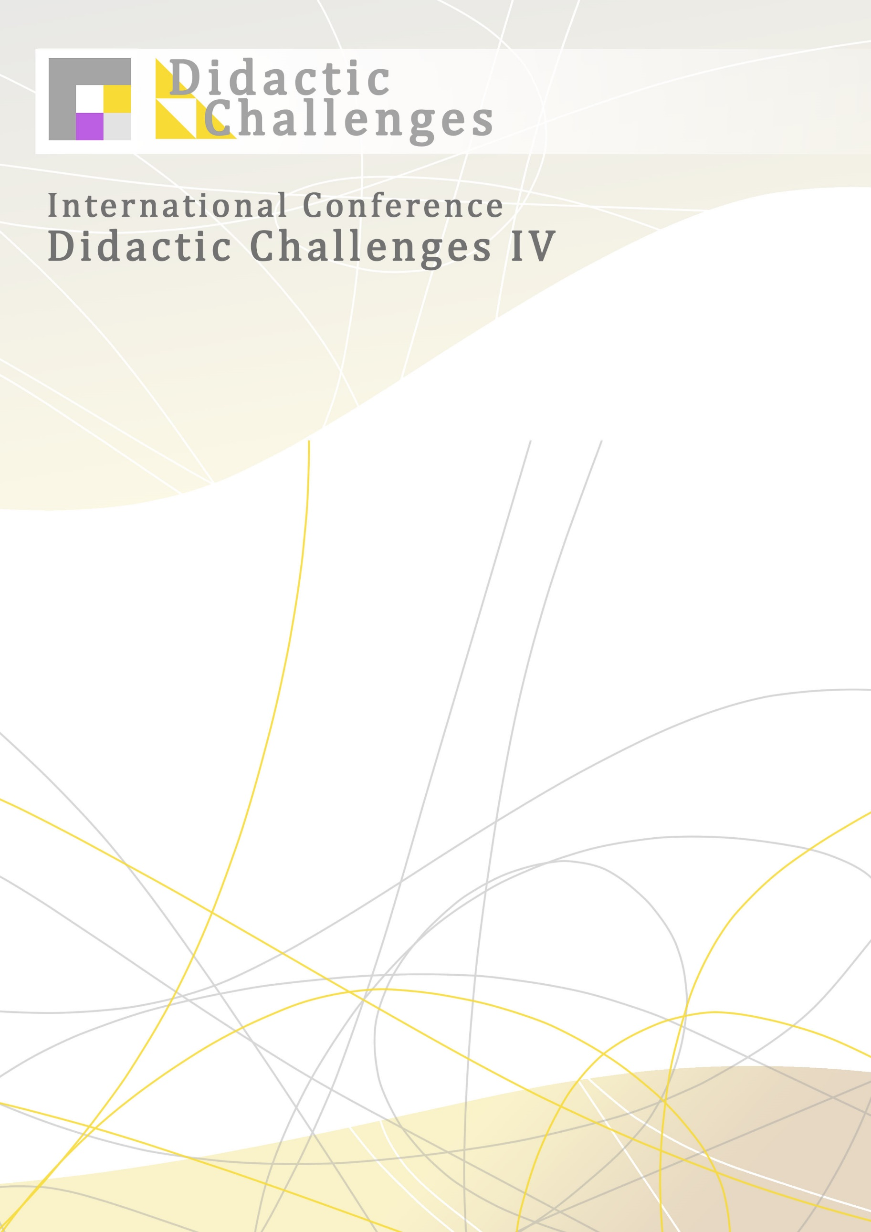

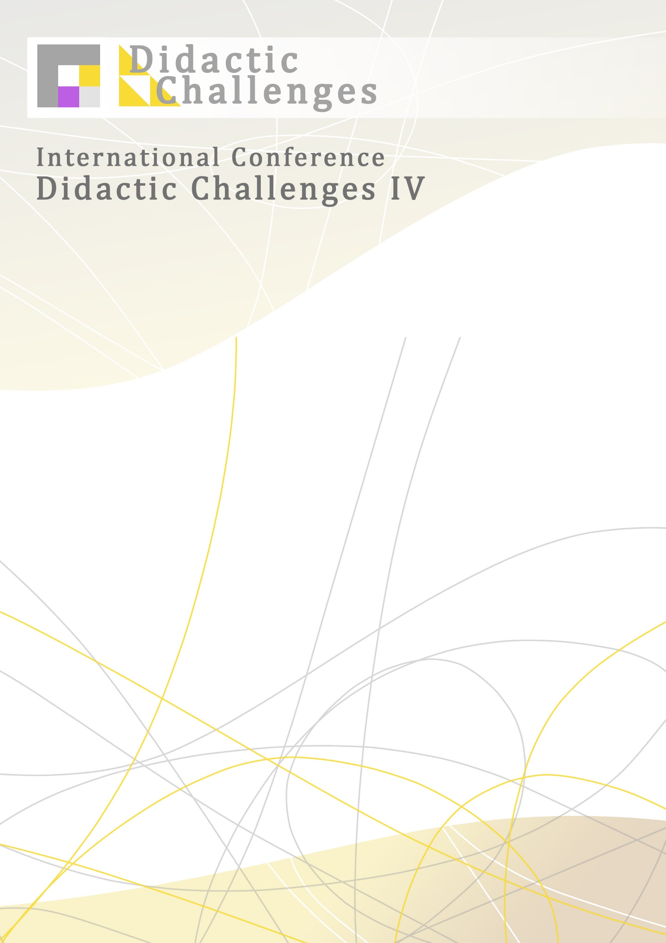
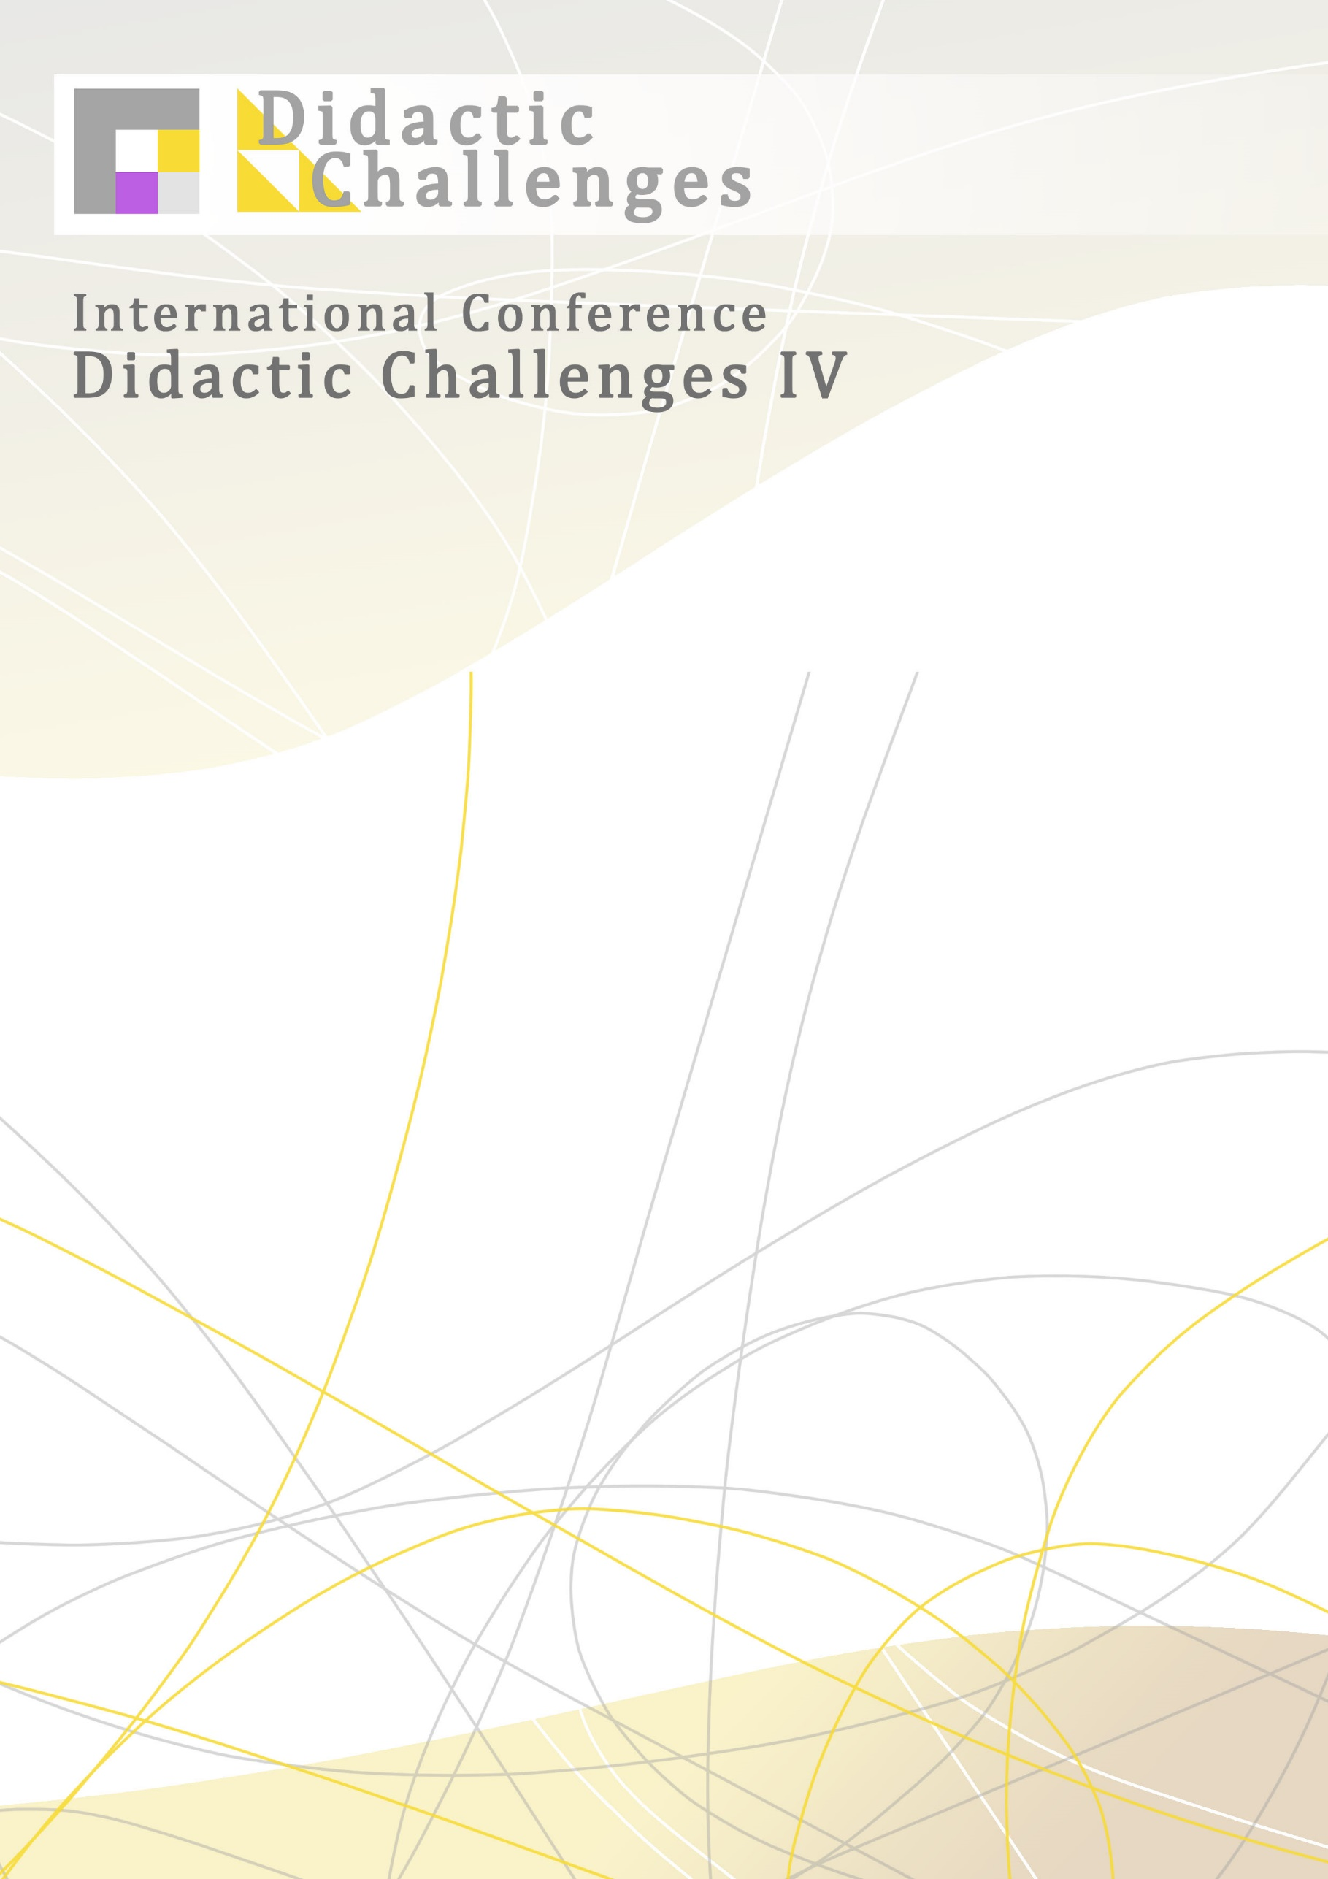
Faculty of Education, Josip Juraj Strossmayer University of Osijek (Republic of Croatia), Croatian Academy of Science and Arts, Center for Scientific Work in Vinkovci (Republic of Croatia), Faculty of Education, University of Maribor (Republic of Slovenia), Faculty of Philosophy, Ss. Cyril and Methodius University (Republic of North Macedonia)
welcome you to the International Scientific Conference

Didactic challenges IV: Futures studies in education
May 26-27, 2022
Osijek, Croatia
Encouraged by a number of challenges that directly or indirectly affect education, we are empowered to predict and explore forthcoming challenges in education, particularly in teaching at all levels of education. While anticipating different scenarios, it is important that we create images of a positive future so that our actions are aligned with the final outcomes of the desired goals. The results of previous research show that positively directed predictions of young people lead the society forward.
Are we focused in our teaching on predicting the role of teachers, educators, professors, pupils and students in the future? Do we anticipate all the ways our role can change in the future? In what social circumstances? How far into the future are we talking about? Is it a time of 10, 50 or 100 years in advance? It is up to us, at this conference, to get as many answers as possible that will help us cope as successfully as possible with the challenges that lie ahead.
Futurological research methods can help us a lot in making more concrete proposals. Nowadays we often use the term futures studies, which, in a scientific way, using a modern methodological approach, allows us to research (predict) the future that has not yet begun. In the range of methods, it is important to select and adapt those that can be most successfully applied in education research, and especially those that we can use in our teaching.
The conference provides an opportunity for scientists and experts from various fields to question these challenges and share with other participants their theoretical knowledge, research results and practical examples.

IMPORTANT DATES:
Abstract submission: February 15 2022

Notification of acceptance: February 25 2022
Conference fee: (600,00 HRK / 80,00 EUR): February 28 2022
Conference fee for students/postgraduates: 300,00 HRK / 40,00 EUR
Conference dates: May 26-27, 2022
Paper submission: May 3, 2022

Official conference languages: Croatia and English
Types of participation: presentation and poster
Invited speakers:
Prof. Sohail Inayatullah, PhD (New Taipei City, Taiwan)
Prof. Milena Ivanuš Grmek, PhD (Maribor, Slovenia)
Asst. Prof. Tomislav Topolovčan, PhD (Zagreb, Croatia)
Assoc. Prof. Renata Jukić, PhD (Osijek, Croatia)

More information on the Conference can be found here:
https://didactic-challenges0.webnode.hr/
Also, we would be very grateful if you would share this information with your colleagues.
We are looking forward to future cooperation.

Assoc. Prof. Snježana Dubovicki, PhD, vice dean, Faculty of Education, Josip Juraj Strossmayer University of Osijek, Chair of the Programme-Organisation Committee of Didactic Challenges IV
Antonija Huljev, PhD Faculty of Education, Josip Juraj Strossmayer University of Osijek, Secretary of Didactic Challenges IV

